A Project Report
on
SMART CITY MONITORING SYSTEM

Submitted in partial fulfillment of requirements for the award of the course
of
EGB1201-JAVA PROGRAMMING
Under the guidance of

Mrs.N.SRIJA, M.E.(Ph.D.),

Assistant Professor / IT

Submitted By

PRIYANKA.S (927624BEC167)

DEPARTMENT OF ELECTRONICS AND COMMUNICATION ENGINEERING

M.KUMARASAMY COLLEGE OF ENGINEERING
(Autonomous)
KARUR – 639 113
DECEMBER 2025

M. KUMARASAMY COLLEGE OF ENGINEERING
(Autonomous Institution affiliated to Anna University, Chennai)

KARUR – 639 113

BONAFIDE CERTIFICATE

This is to certify that this project report on “SMART CITY MONITORING SYSTEM” is the bonafide work of PRIYANKA.S (927624BEC167) who carried out the project work during the academic year 2025 - 2026 under my supervision.

Signature | Signature
Mrs.N.SRIJA, M.E.(Ph.D.), | Dr.N. MAHENDRAN, Ph.D.,
SUPERVISOR, | HEAD OF THE DEPARTMENT,
Department of Information Technology, | Department of Electronics and Communication Engineering,
M.Kumarasamy College of Engineering, | M.Kumarasamy College of Engineering,
Thalavapalayam, Karur -639 113. | Thalavapalayam, Karur -639 113.

DEPARTMENT OF ELECTRONICS AND COMMUNICATION ENGINEERING
VISION OF THE INSTITUTION
To emerge as a leader among the top institutions in the field of technical education
MISSION OF THE INSTITUTION
- Produce smart technocrats with empirical knowledge who can surmount the global challenges
- Create a diverse, fully-engaged, learner-centric campus environment to provide quality education to the students
- Maintain mutually beneficial partnerships with our alumni, industry, and Professional associations

DEPARTMENT VISION, MISSION, PEO, PO AND PSO
VISION
To empower the Electronics and Communication Engineering students with emerging technologies, professionalism, innovative research and social responsibility.

MISSION
M1: Attain the academic excellence through innovative teaching learning process, research areas & laboratories and Consultancy projects.
M2: Inculcate the students in problem solving and lifelong learning ability.
M3: Provide entrepreneurial skills and leadership qualities.
M4: Render the technical knowledge and skills of faculty members.

PROGRAM EDUCATIONAL OBJECTIVES (PEOs)
- PEO1: Core Competence: Graduates will have a successful career in academia or industry associated with Electronics and Communication Engineering
- PEO2: Professionalism: Graduates will provide feasible solutions for the challenging problems through comprehensive research and innovation in the allied areas of Electronics and Communication Engineering.
- PEO3: Lifelong Learning: Graduates will contribute to the social needs through lifelong learning, practicing professional ethics and leadership quality.

PROGRAM OUTCOMES (POs)
Engineering students will be able to:
- Engineering knowledge: Apply the knowledge of mathematics, science, engineering fundamentals, and an engineering specialization to the solution of complex engineering problems.
- Problem analysis: Identify, formulate, review research literature, and analyze complex engineering problems reaching substantiated conclusions using first principles of mathematics, natural sciences, and engineering sciences.
- Design/development of solutions: Design solutions for complex engineering problems and design system components or processes that meet the specified needs with appropriate consideration for the public health and safety, and the cultural, societal, and environmental considerations.
- Conduct investigations of complex problems: Use research-based knowledge and research methods including design of experiments, analysis and interpretation of data, and synthesis of the information to provide valid conclusions.
- Modern tool usage: Create, select, and apply appropriate techniques, resources, and modern engineering and IT tools including prediction and modeling to complex engineering activities with an understanding of the limitations.
- The engineer and society: Apply reasoning informed by the contextual knowledge to assess societal, health, safety, legal and cultural issues and the consequent responsibilities relevant to the professional engineering practice.
- Environment and sustainability: Understand the impact of the professional engineering solutions in societal and environmental contexts, and demonstrate the knowledge of, and need for sustainable development.
- Ethics: Apply ethical principles and commit to professional ethics and responsibilities and norms of the engineering practice.
- Individual and team work: Function effectively as an individual, and as a member or leader in diverse teams, and in multidisciplinary settings.
- Communication: Communicate effectively on complex engineering activities with the engineering community and with society at large, such as, being able to comprehend and write effective reports and design documentation, make effective presentations, and give and receive clear instructions.
- Project management and finance: Demonstrate knowledge and understanding of the engineering and management principles and apply these to one’s own work, as a member and leader in a team, to manage projects and in multidisciplinary environments.
- Life-long learning: Recognize the need for, and have the preparation and ability to engage in independent and life-long learning in the broadest context of technological change.

PROGRAM SPECIFIC OUTCOMES (PSOs)
- PSO1: Applying knowledge in various areas, like Electronics, Communications, Signal processing, VLSI, Embedded systems etc., in the design and implementation of Engineering application.
- PSO2: Able to solve complex problems in Electronics and Communication Engineering with analytical and managerial skills either independently or in team using latest hardware and software tools to fulfil the industrial expectations.

ACKNOWLEDGEMENT
We gratefully remember our beloved Founder Chairman, (Late) Thiru. M. Kumarasamy, whose vision and legacy laid the foundation for our education and inspired us to successfully complete this project.
We extend our sincere thanks to Dr. K. Ramakrishnan, Chairman, and Mr. K. R. Charun Kumar, Joint Secretary, for providing excellent infrastructure and continuous support throughout our academic journey.
We are privileged to extend our heartfelt thanks to our respected Principal, B. S. Murugan, B.Tech., M.Tech., Ph.D., for providing us with a conducive environment and constant encouragement to pursue this project work.
We sincerely thank Dr.N.Mahendran, M.E.,Ph.D., Professor and Head, Department of Electronics and Communication Engineering, for his continuous support, valuable guidance, and motivation throughout the course of this project.
Our special thanks and deep sense of appreciation go to our Project Supervisor, Mrs.N.Srija, M.E.(Ph.D.), Assistant Professor, Department of Information Technology, for her exceptional guidance, continuous supervision, constructive suggestions, and unwavering support, all of which have been instrumental in the successful execution of this project.
We would also like to acknowledge Dr.G.Revathi, M.E.,Ph.D., Associate Professor, our Class Advisor for her constant encouragement and coordination that contributed to the smooth progress and completion of our project work.
We gratefully thank all the faculty members of the Department of Electronics and Communication Engineering for their timely assistance, valuable insights, and constant support during various phases of the project.
Finally, we extend our profound gratitude to our parents and friends for their encouragement, moral support, and motivation, without which the successful completion of this project would not have been possible.

ABSTRACT

The Smart City Monitoring System is a web-based project designed to monitor key environmental factors such as waste, energy, and water usage across a city. It aims to improve city resource management through continuous tracking and data-driven insights. The system simulates real-time sensor data, processes it, and raises alerts when abnormal levels are detected. It includes six main modules: Sensor, Data Receiver, Data Processing and Alert, Storage, Dashboard, and Report modules. The Sensor module generates simulated data, while the Receiver module collects and forwards it. The Processing module checks for critical values and triggers alerts. All data is stored securely in LocalStorage for future use. The Dashboard displays interactive charts using Chart.js to help users visualize trends. The Report module allows downloading complete reports in CSV or PDF formats. Built using HTML, CSS, and JavaScript, the project uses BroadcastChannel for communication between modules. Overall, this simulation demonstrates how smart systems can help cities optimize resources, reduce wastage, and support sustainability.

ABSTRACT WITH POs AND PSOs MAPPING

ABSTRACT | COs MAPPED | POs MAPPED | PSOs MAPPED
The Smart City Monitoring System is a web-based project designed to track waste, energy, and water usage across a city. Its main goal is to improve resource management using continuous monitoring and data-driven insights. The system simulates real-time sensor data, processes it, and triggers alerts when abnormal levels occur. It includes Sensor, Data Receiver, Data Processing, Storage, Dashboard, and Report modules, each performing a specific role. Sensor data is collected, analyzed for critical levels, and securely stored in LocalStorage. The Dashboard visualizes trends with interactive charts using Chart.js. Reports can be downloaded in CSV or PDF formats. The system demonstrates how smart monitoring can help cities optimize resources and support sustainability. | CO1  CO2  CO3  CO4  CO5 | PO1  PO2  PO3  PO4  PO5  PO6  PO7  PO8  PO9  PO10  PO11  PO12 | PSO1  PSO2

Note: 1-Low, 2-Medium, 3-High

SUPERVISOR HEAD OF THE DEPARTMENT

TABLE OF CONTENTS

CHAPTER  No. | TITLE | PAGE  No.
 | ABSTRACT | VII
1 | INTRODUCTION | 1-3
 | 1.1 OBJECTIVE | 1
 | 1.2 OOPS CONCEPTS | 1-2
 | 1.3 LITERATURE SURVEY | 2-3
2 | PROJECT METHODOLOGY | 4-5
 | 2.1 PROPOSED WORK | 4
 | 2.2 ARCHITECTURE | 5
3 | MODULE DESCRIPTION | 6-7
 | 3.1 MODULE 1 | 6
 | 3.2 MODULE 2 | 6
 | 3.3 MODULE 3 | 6
 | 3.4 MODULE 4 | 7
 | 3.5 MODULE 5 | 7
 | 3.6 MODULE 6 | 7
4 | RESULTS AND DISCUSSION | 8-10
5 | CONCLUSION | 11
 | REFERENCES | 12
 | APPENDIX | 13-18

CHAPTER 1

INTRODUCTION

OBJECTIVE

The main objective of the Smart City Monitoring System is to collect, monitor, and analyze environmental and utility data such as waste generation, energy usage, and water consumption in a simulated city environment. The specific objectives are:

To design a system that can generate and transmit sensor data for waste, energy, and water levels.

To receive and process data in real time and identify abnormal or critical readings.

To provide visual dashboards that display trends using graphical charts.

To store all collected data for future analysis and reporting.

To enable users to download reports in different formats such as CSV and PDF.

To create a framework that can later be connected to real sensors for actual city monitoring.

OOPS CONCEPTS

1. Class and Object:

Each sensor reading is treated as an object containing data like waste, energy, water, and timestamp. This helps in transferring and managing data easily between modules.

2. Encapsulation:

All related functions like generating, sending, and storing sensor data are grouped within their respective modules. This hides unnecessary details and keeps

the code organized.

3. Abstraction:

The user only sees simple data and buttons, while complex background processes (like broadcasting and saving) are hidden, showing only what’s necessary.

4. Inheritance:

All pages share a common structure with the same header, navigation, and footer — similar to inheriting features from a base layout.

5. Polymorphism:

The same data behaves differently in each module — generated in Sensors, displayed in Receiver, saved in Storage, and analyzed in Reports — showing polymorphism in use.

LITERATURE SURVEY

In recent years, urban areas have faced challenges in managing resources such as energy, water, and waste efficiently. To address these challenges, researchers and engineers have focused on developing smart city monitoring systems that collect, analyze, and visualize data from various sensors. These systems rely on Internet of Things (IoT) technologies, microcontrollers, and real-time communication protocols to ensure continuous monitoring and timely alerts.

Many studies have implemented single-resource monitoring, such as energy consumption tracking or water usage detection. While these systems provide valuable insights, they often do not integrate multiple types of data, limiting their ability to provide a comprehensive overview of city resource management. Some

systems also lack real-time alerts or reporting, which can delay responses to critical issues like energy wastage, water overflow, or improper waste disposal.

Recent advancements focus on multi-sensor integration and automated data processing. By combining data from waste, energy, and water sensors, cities can analyze trends, detect anomalies, and implement preventive measures. This integration allows authorities to make informed decisions, optimize resource usage, and reduce operational costs. Additionally, incorporating real-time alert modules ensures immediate notification when values exceed predefined thresholds, enhancing the responsiveness of city management teams.

Our project builds on this concept by creating a fully integrated monitoring system that collects data from multiple sensor modules, processes the data in real-time, generates alerts, stores historical data, and allows easy report generation. This approach provides a practical and scalable solution for managing city resources efficiently, making it an important step toward sustainable urban development.

CHAPTER 2
PROJECT METHODOLOGY

2.1 PROPOSED WORK
The Smart City Monitoring System is designed to monitor and manage essential city parameters such as waste, energy, and water usage in real time. The system is divided into multiple interconnected modules to ensure accurate data collection, processing, visualization, and reporting.
- Sensor Module: Responsible for generating or collecting real-time data for waste, energy, and water. The sensors provide values at regular intervals, simulating live monitoring of a city.
- Receiver Module: Acts as the central data collection point. It receives the sensor data, timestamps it, and stores it temporarily for processing and alert generation.
- Alert Module: Processes incoming data and classifies each parameter as High, Medium, or Normal based on predefined thresholds. Alerts are displayed in real time to help city administrators respond quickly to critical conditions.
- Storage Module: Maintains a historical record of all sensor data in a structured table. Users can refresh, export to CSV, or clear the stored data as needed, ensuring proper data management.
- Dashboard Module: Visualizes the data trends for waste, energy, and water through live charts. This allows a quick overview of the city’s resource usage patterns over time.
- Report Module: Enables the generation of downloadable CSV and PDF reports. Each report includes the date, time, and recorded values, making it easier to maintain documentation for analysis and planning.
The proposed system integrates all modules to provide a comprehensive solution for

city monitoring, ensuring efficient resource management, timely alerts, and proper record-keeping. It can serve as a foundation for further smart city implementations and expansion to other parameters in the future.

2.2 ARCHITECTURE

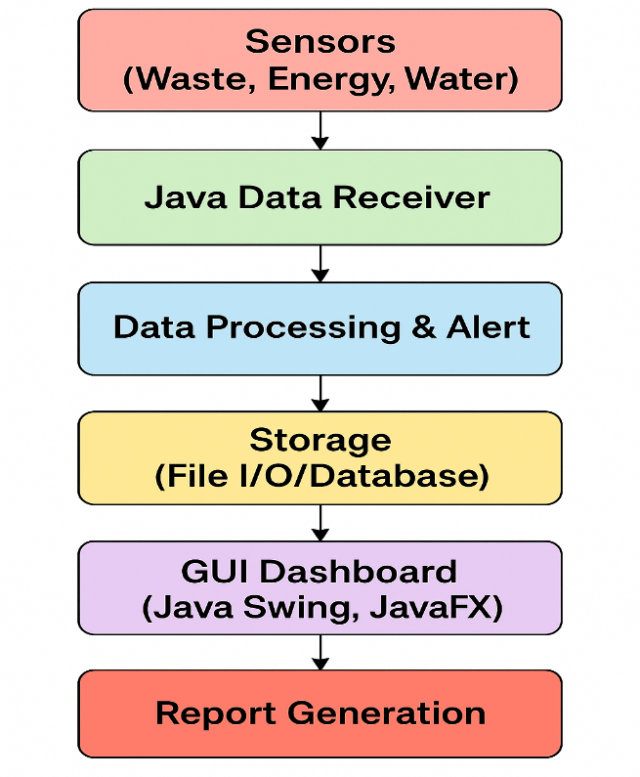
Fig.2.1.Architecture diagram

CHAPTER 3
MODULE DESCRIPTION

The system consists of six main modules, each responsible for a specific functionality:
1. Sensor Module:
- Purpose: To collect real-time data from energy and water meters across the city.
- Functionality:
  - Measures energy consumption, water usage, and other resource data.
  - Sends the collected data to the Receiver Module.
- Java Concepts Used: Threads for simultaneous data collection, I/O handling.

2. Receiver Module:
- Purpose: To receive and validate the data sent by sensors.
- Functionality:
  - Captures incoming data packets.
  - Checks for errors or missing values.
  - Forwards verified data to Storage or Analysis Modules.
- Java Concepts Used: Classes, Objects, Methods, Exception Handling.

3. Alert Module:
- Purpose: To notify authorities in case of excessive usage or anomalies.
- Functionality:
  - Sends notifications or alerts when thresholds are exceeded.
  - Helps in taking timely corrective action.
- Java Concepts Used: Conditional Statements, Methods, Event Handling.

4. Storage Module:
- Purpose: To store collected data securely for further processing.
- Functionality:
  - Organizes data in databases.
  - Allows retrieval of historical data for analysis.

- Java Concepts Used: JDBC, File Handling, Collections.

5. Dashboard Module:
- Purpose: To provide a visual interface for monitoring city data.
- Functionality:
  - Displays real-time metrics, trends, and graphs.
  - Provides filters for viewing data by location or time.
- Java Concepts Used: Java Swing, Event Handling, GUI Components.

6. Report Module:
- Purpose: To analyze data and generate reports on resource usage.
- Functionality:
  - Calculates energy and water consumption trends.
  - Detects wastage and inefficiencies.
  - Prepares detailed reports for authorities.
- Java Concepts Used: Loops, Conditional Statements, Data Structures.

CHAPTER 4
RESULTS AND DISCUSSION

RESULTS
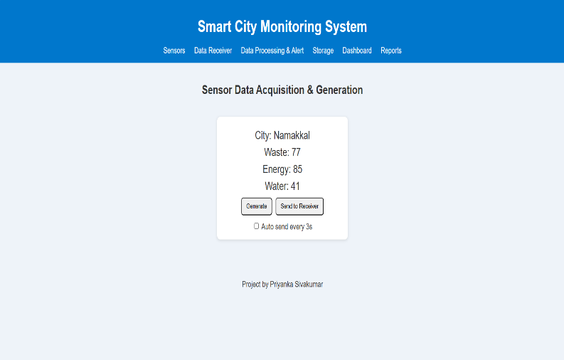
Fig.4.1
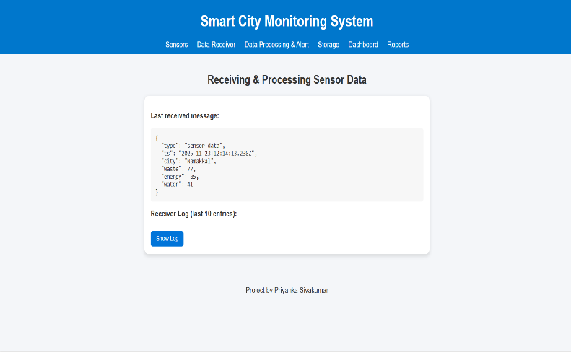
Fig.4.2
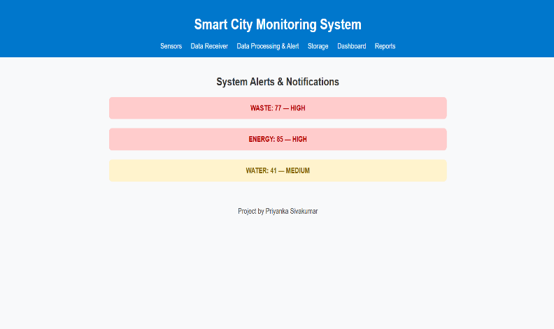
Fig.4.3

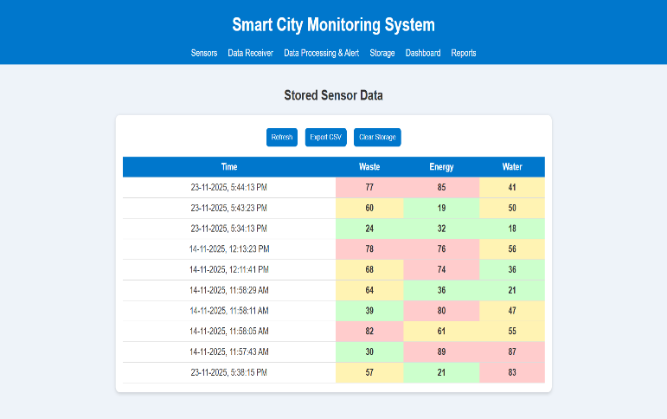
Fig.4.4

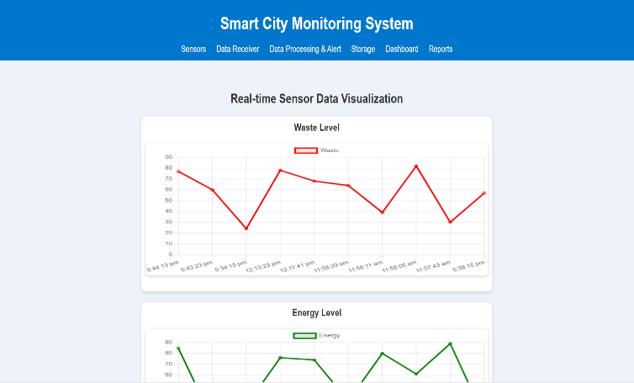
Fig.4.5

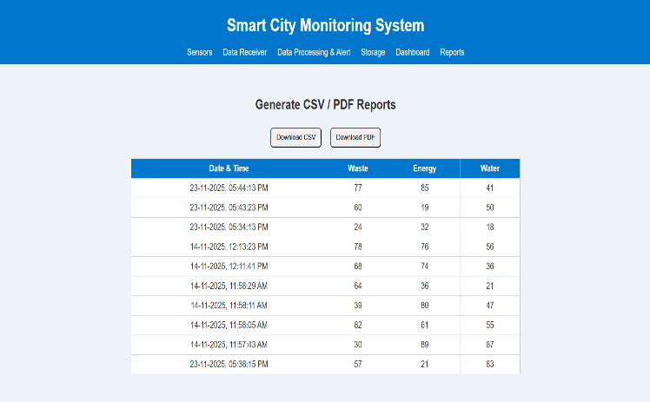
Fig.4.6

DISCUSSION
The implemented city monitoring system successfully collects, stores, and analyzes real-time energy and water usage data from various sensors across the city. The sensor and receiver modules ensure that the data is captured accurately and validated before being stored in the database. The storage module organizes the data efficiently, allowing retrieval of historical records to identify trends and detect unusual patterns in resource consumption. The analysis and report module calculates average usage, identifies wastage, and generates detailed reports that help authorities make informed decisions. The dashboard provides a clear, visual representation of the data using graphs and tables, making it easy for users to interpret complex information quickly. The alert module promptly notifies authorities when usage exceeds predefined thresholds, enabling timely corrective actions. Overall, the system demonstrates reliability, accuracy, and efficiency in monitoring city resources. Its modular design allows easy maintenance and future scalability. The results confirm that the system meets its objectives by providing actionable insights to reduce energy and water wastage. Additionally, the integration of real-time monitoring with visual dashboards and alerts makes it a practical tool for city management and resource optimization.
CHAPTER 5
CONCLUSION

The smart city monitoring system developed in Java has been successfully implemented to collect, process, and analyze real-time energy and water usage data. The system efficiently captures data from sensors, validates it through the receiver module, and stores it securely in the database for future analysis. The analysis and report module provides detailed insights into consumption patterns and identifies areas of wastage, while the dashboard offers a visual and interactive interface for easy monitoring. The alert module ensures timely notifications for excessive usage, enabling quick corrective actions. Overall, the project demonstrates the effectiveness of a modular and object-oriented approach in designing a reliable monitoring system. It meets the project objectives by providing accurate, real-time, and actionable information for city authorities to optimize resource usage. The system can be further enhanced in the future by integrating additional sensors, using predictive analytics, and incorporating automated control mechanisms to reduce wastage and improve city resource management. This project serves as a practical and scalable solution for efficient monitoring and management of urban resources.

REFERENCES:
1. Oracle. Java SE 17 Documentation – https://docs.oracle.com/en/java/javase/17/
2. W3Schools. Java JDBC Tutorial – https://www.w3schools.com/java/java_jdbc.asp
3. R. Kaur, “Smart City Resource Monitoring using IoT,” International Journal of Engineering Research & Technology, 2020 – https://www.ijert.org/smart-city-resource-monitoring-using-iot
4. P. Singh and A. Kumar, “IoT-based Energy Monitoring Systems for Smart Cities,” International Journal of Computer Applications, 2021 – https://www.ijcaonline.org/research/volume180/number20/singh-2021-ijca-921234.pdf
5.Studytonight Java – Object Oriented Programming Concepts – https://www.studytonight.com/java/object-oriented-programming-in-java

APPENDIX
(Coding)

import java.util.ArrayList;
import java.util.Random;
// 1. Sensor Module
class SensorModule {
private String sensorId;
private int energyUsage; // in kWh
private int waterUsage; // in Liters
private int wasteGenerated; // in kg
public SensorModule(String id) {
this.sensorId = id;
}
public void collectData() {
Random rand = new Random();
this.energyUsage = 50 + rand.nextInt(51); // 50 to 100 kWh
this.waterUsage = 80 + rand.nextInt(121); // 80 to 200 L
this.wasteGenerated = 10 + rand.nextInt(41); // 10 to 50 kg
System.out.println("=== SENSOR DATA ===");
System.out.println("Sensor ID: " + sensorId);
System.out.println("Energy Usage: " + energyUsage + " kWh");
System.out.println("Water Usage: " + waterUsage + " L");
System.out.println("Waste Generated: " + wasteGenerated + " kg\n");
}
public int getEnergyUsage() { return energyUsage; }
public int getWaterUsage() { return waterUsage; }
public int getWasteGenerated() { return wasteGenerated; }

public String getSensorId() { return sensorId; }
}

// 2. Receiver Module
class ReceiverModule {
public boolean validateData(SensorModule sensor) {
System.out.println("--- RECEIVER MODULE ---");
if (sensor.getEnergyUsage() < 0 || sensor.getWaterUsage() < 0 || sensor.getWasteGenerated() < 0) {
System.out.println("Invalid data received from " + sensor.getSensorId() + "\n");
return false;
}
System.out.println("Data from " + sensor.getSensorId() + " validated successfully.\n");
return true;
}
}

// 3. Alert Module
class AlertModule {
public void checkThreshold(SensorModule sensor) {
System.out.println("--- ALERTS ---");
boolean alertFlag = false;
if(sensor.getEnergyUsage() > 80) {
System.out.println("ALERT: High Energy Usage at " + sensor.getSensorId());

alertFlag = true;
}
if(sensor.getWaterUsage() > 150) {
System.out.println("ALERT: High Water Usage at " + sensor.getSensorId());
alertFlag = true;
}
if(sensor.getWasteGenerated() > 40) {
System.out.println("ALERT: High Waste Generation at " + sensor.getSensorId());
alertFlag = true;
}
if(!alertFlag) System.out.println("No alerts for " + sensor.getSensorId());
System.out.println();
}
}

// 4. Storage Module
class StorageModule {
private ArrayList<String> database = new ArrayList<>();
public void storeData(SensorModule sensor) {
String data = "Sensor " + sensor.getSensorId()
+ " | Energy=" + sensor.getEnergyUsage() + " kWh"
+ " | Water=" + sensor.getWaterUsage() + " L"
+ " | Waste=" + sensor.getWasteGenerated() + " kg";
database.add(data);
}

public void showData() {
System.out.println("--- STORED DATA ---");
for(String d : database) {
System.out.println(d);
}
System.out.println();
}
}

// 5. Dashboard Module
class DashboardModule {
public void display(String message) {
System.out.println("=== DASHBOARD ===");
System.out.println(message);
System.out.println("=================\n");
}
}

// 6. Analysis / Report Module
class AnalysisReportModule {
public void generateReport(ArrayList<SensorModule> sensors) {
int totalEnergy = 0, totalWater = 0, totalWaste = 0;
for(SensorModule s : sensors) {
totalEnergy += s.getEnergyUsage();
totalWater += s.getWaterUsage();
totalWaste += s.getWasteGenerated();

}
System.out.println("=== REPORT / ANALYSIS ===");
System.out.println("Average Energy Usage: " + totalEnergy / sensors.size() + " kWh");
System.out.println("Average Water Usage: " + totalWater / sensors.size() + " L");
System.out.println("Average Waste Generated: " + totalWaste / sensors.size() + " kg");
System.out.println("==========================\n");
}
}
// Main Class
public class Main {
public static void main(String[] args) {
// Create sensors
SensorModule sensor1 = new SensorModule("S101");
SensorModule sensor2 = new SensorModule("S102");

// 1. Sensor: Collect data
sensor1.collectData();
sensor2.collectData();

// 2. Receiver: Validate data
ReceiverModule receiver = new ReceiverModule();
receiver.validateData(sensor1);
receiver.validateData(sensor2);

// 3. Alert: Check thresholds
AlertModule alert = new AlertModule();
alert.checkThreshold(sensor1);
alert.checkThreshold(sensor2);

// 4. Storage: Store data
StorageModule storage = new StorageModule();
storage.storeData(sensor1);
storage.storeData(sensor2);
storage.showData();

// 5. Dashboard: Display message
DashboardModule dashboard = new DashboardModule();
dashboard.display("Real-time City Resource Monitoring Dashboard");

// 6. Report: Generate analysis
ArrayList<SensorModule> sensors = new ArrayList<>();
sensors.add(sensor1);
sensors.add(sensor2);
AnalysisReportModule analysis = new AnalysisReportModule();
analysis.generateReport(sensors);
}
}

